The MPS PTFA Fun Run 2026: Sponsorship Form

Full name of person running _________________________________________

This year's Melbourn Fun Run isn't just about crossing the finish line - it's about coming together as a community to support our local school and create something special for our children. By sponsoring one of our runners, you'll be helping raise vital funds for Melbourn Primary School PTFA, enabling us to provide new resources, exciting events and enriching opportunities for every child.

Every contribution, big or small, helps fuel our runners' motivation and brings us closer to our fundraising goals. If you know someone taking part, why not cheer them on with a donation and be part of the positive impact we're making together?

Lets run, support, and celebrate as a village!

Thank you for sponsoring our event. Please return all cash sponsorship in an envelope along with this sponsor form, and post it in the PTFA post box at the school front office by Friday 22nd May 2026 . Alternatively, you can pay online using the QR code below or via our Collctiv page at https://pay.collctiv.com/melbourn-primary-school-ptfa-fun-run-2026-38363

Gift Aid: Make your donation worth up to 25% more. Please note, you must be a taxpayer paying more tax than we reclaim in order for us to claim Gift Aid from your sponsorship. All fields in the below table are mandatory for us to make a Gift Aid claim.

 Collctiv - online sponsorship 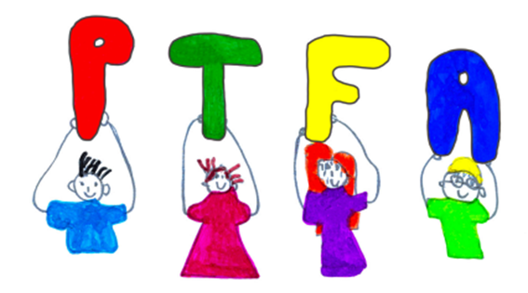
Title | Forename | Surname | Home Address | Postcode | Amount | Gift Aid?  (please tick) | Tick if paid Cash/  Cheque | Tick if  Paid online

